**Data Analysis:** Sustainable Supply Chain Performance Dashboard in Power BI

**Task 1 (20/01/2025): Creating Multiple Tables using Duplicating Original Table.**

Step1: Load the Data using “Get Data” feature in Home Tab

Step2: Click “Transform Data” in Home Tab and another window called power query will be opened.

Step3: Left side of window you can see Query table. Right click and duplicate. Rename it as given in word Document.

Step4: select and delete the rows which are not required in that word document for that table.

Step5: Go to home tab -> then click on close and apply button to reflect the changes made in power query window. And finally save the Power BI file.

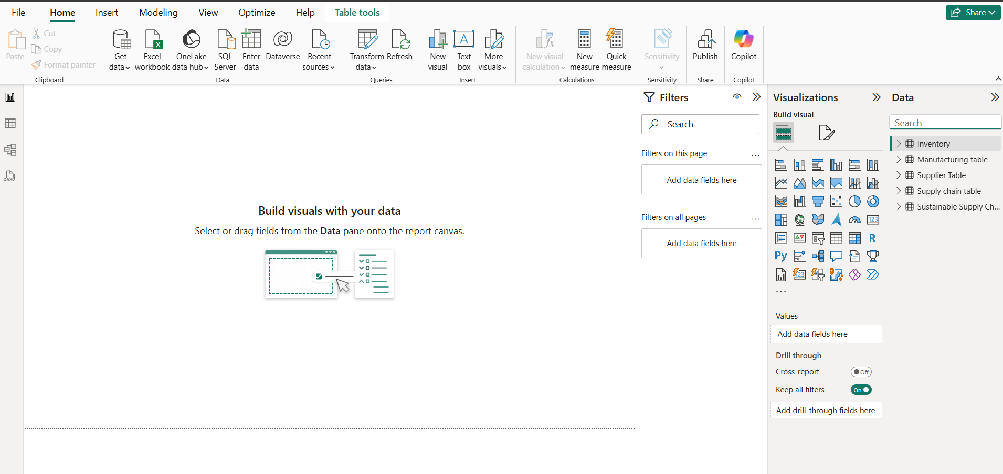

Fig 1.1: final tables created by duplicating 1 table